Step 1: Go to: https://harvard.bluera.com/harvard/
Under Tasks there will be a list of courses for Question Personalization (example below):

Step 2: When you click on the course, you will see the following screen.
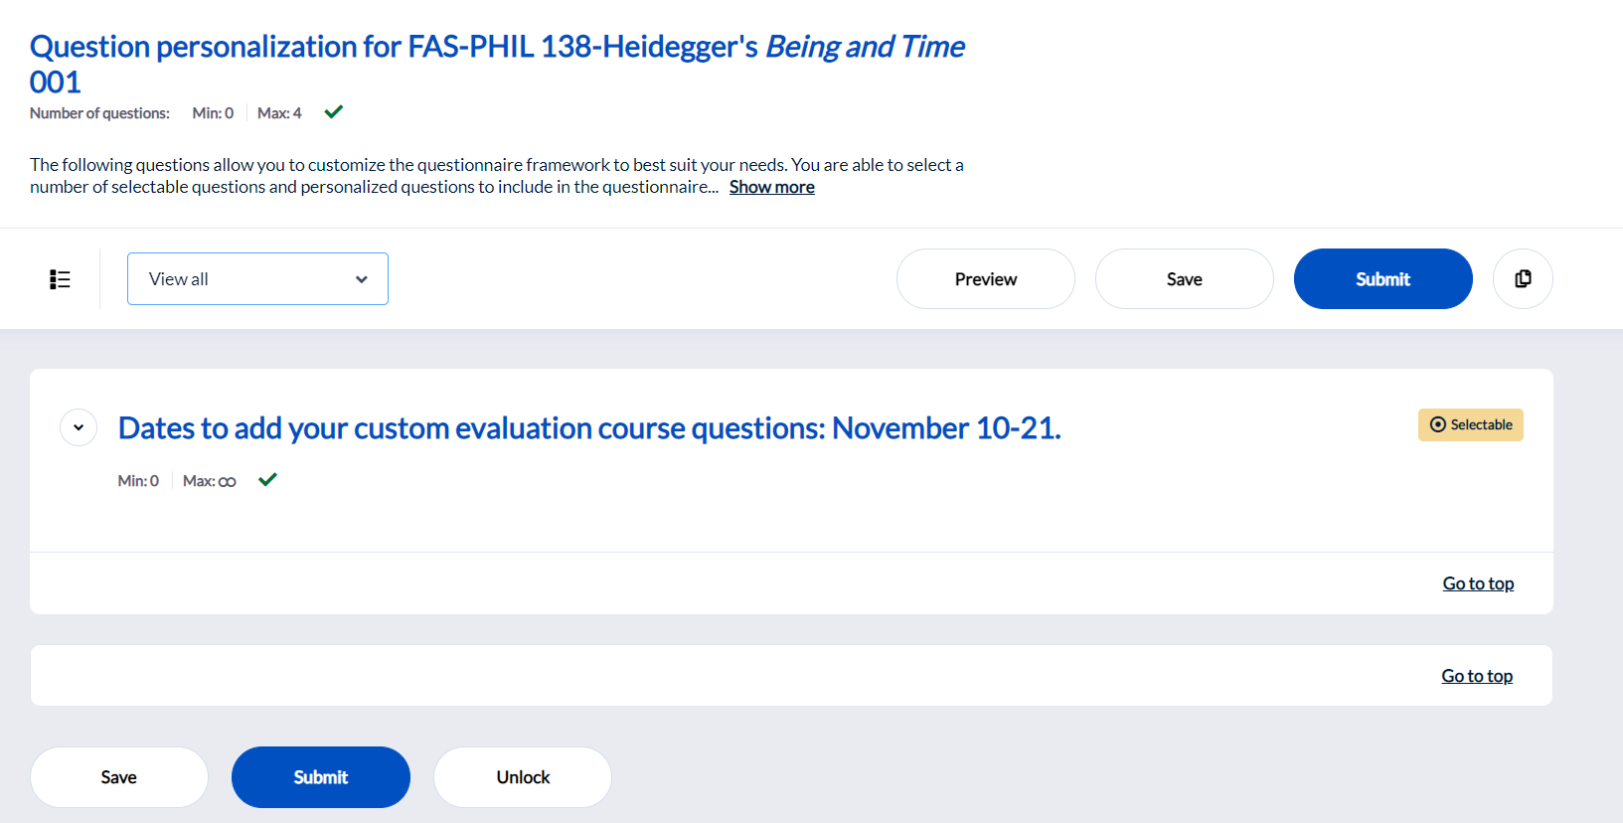
Step 3: On the drop-down menu at the top, click “View Customizable”.
You will see all the scales available for adding personalized questions. You can add up to 3 personalized questions.

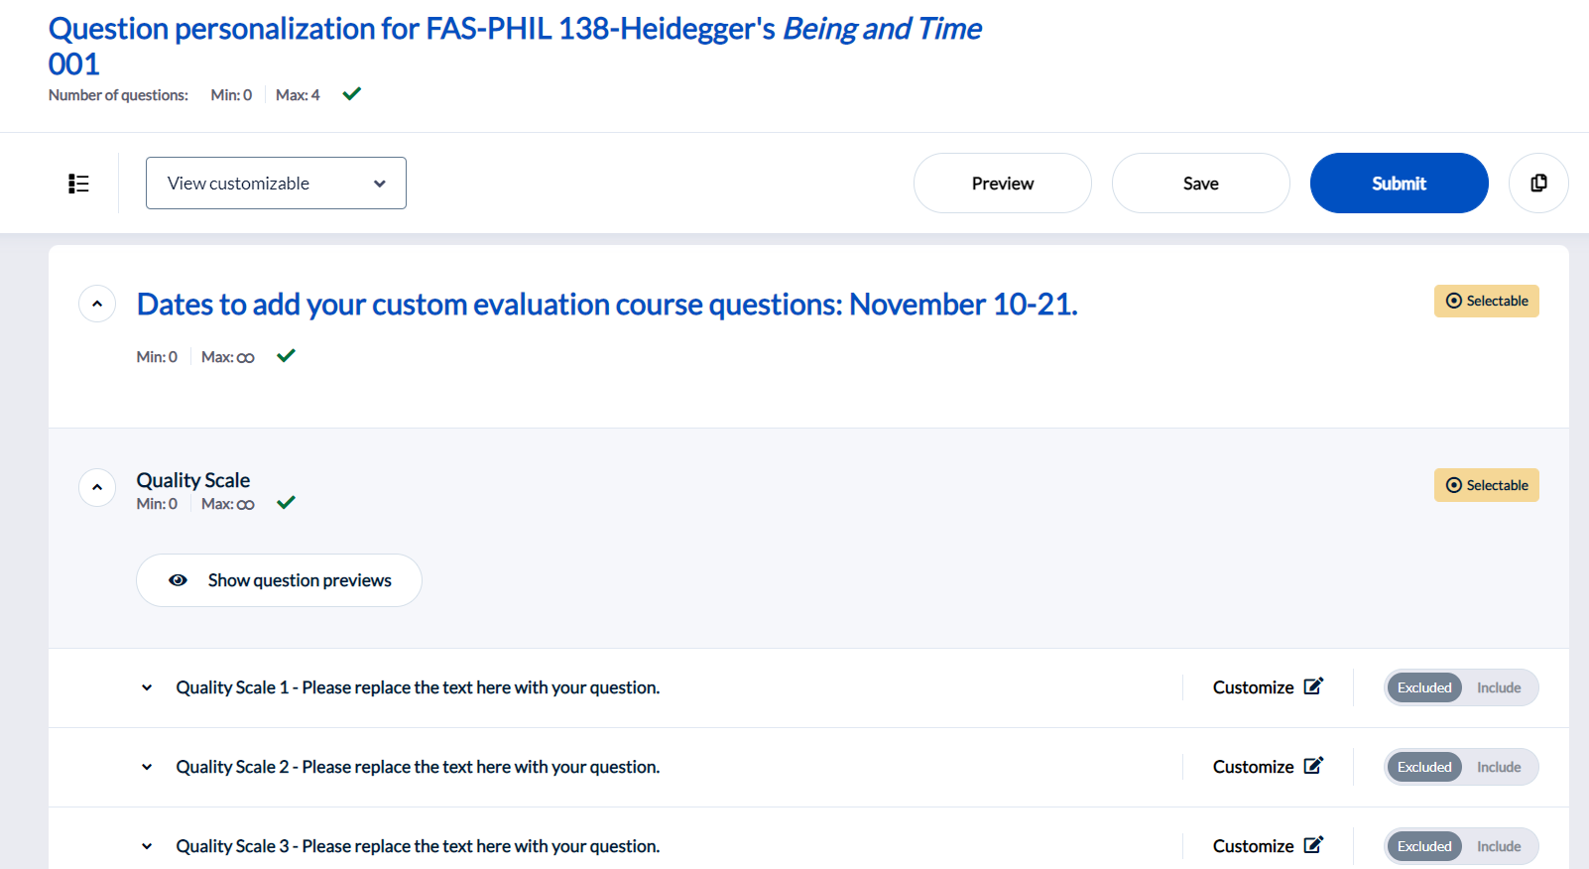
Step 4: Click the Customize icon next to the type of question you want to add. You will see the Question editor below.
Step 5: Type in the text in the box with the cursor.

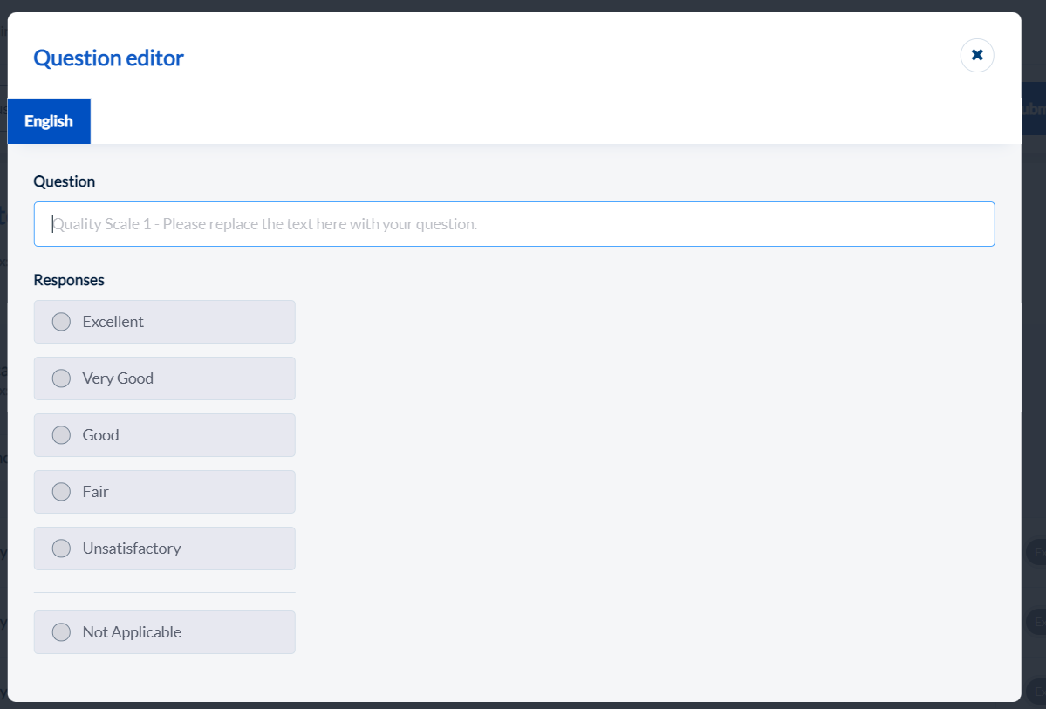
Step 6: After you type the question text at cursor. Click the “X” in the upper right corner when you are done.
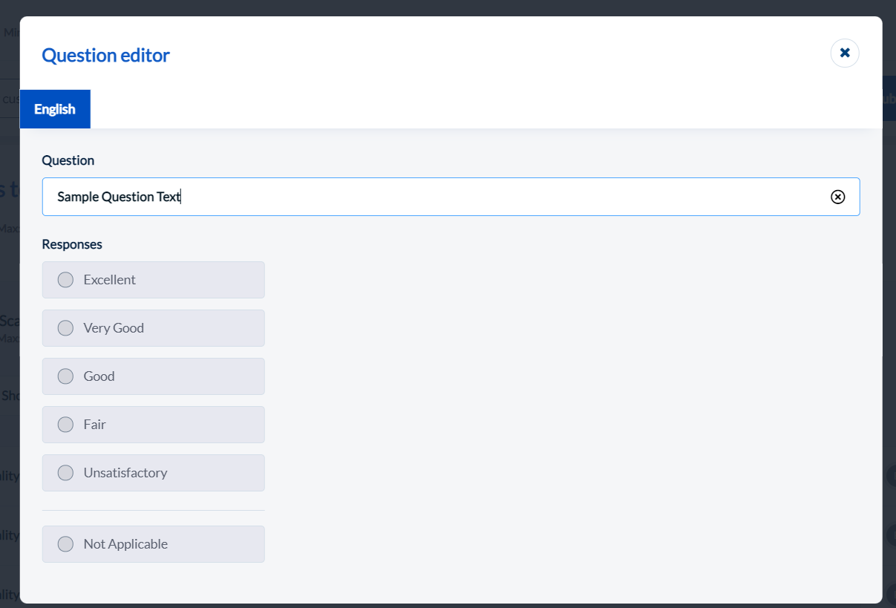
Step 7: After you click the “X”, the question you typed in will have a green toggle switch saying “Included”.
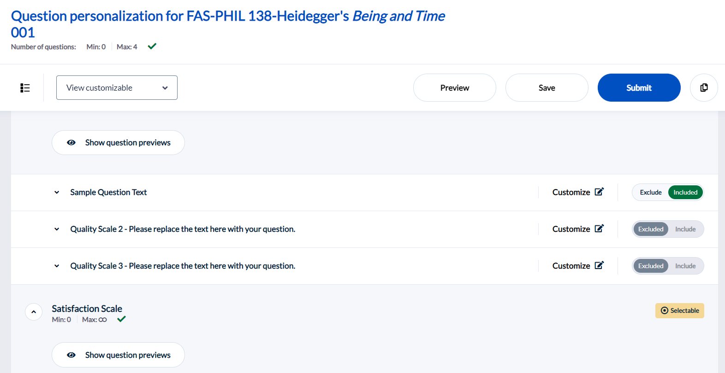
Step 8: You can click “Preview” to view the course evaluation form including the added personalized questions.
Step 9: You can click “Save” if you are not finished and want to return to edit questions.
Step 10: If you enter more than 3 personalized questions, all your questions will not appear on the course evaluation.
Step 11: When you have completed all your personalized questions, click the blue “Submit “button to finalize and submit so that questions appear on course evaluation.
If you do not click “Submit”, the personalized questions marked “Include”, including “What would you like to tell future students about this class?” will not appear on the course evaluation.
The “Submit” button appears at the top and the bottom of the page.


